**1. Download the dataset: Dataset**

**2. Load the dataset.**

import numpy as np

import pandas as pd

df = pd.read_csv("/Churn_Modelling.csv")

**3. Perform Below Visualizations.**

● **Univariate Analysis**

import seaborn as sns

sns.histplot(df.EstimatedSalary,kde=True)

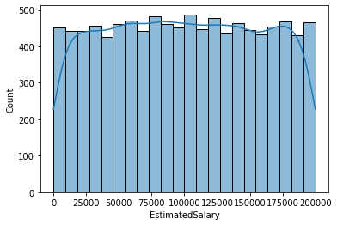

● **Bi - Variate Analysis**

import seaborn as sns

import matplotlib.pyplot as plt

sns.scatterplot(df.Balance,df.EstimatedSalary)

plt.ylim(0,15000)

C:\Users\ELCOT\anaconda3\lib\site-packages\seaborn\_decorators.py:36: FutureWarning: Pass the following variables as keyword args: x, y. From version 0.12, the only valid positional argument will be `data`, and passing other arguments without an explicit keyword will result in an error or misinterpretation.

warnings.warn(

(0.0, 15000.0)

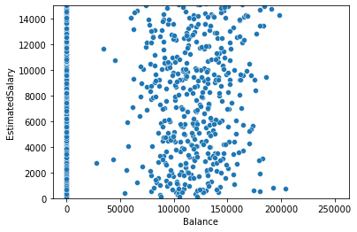

● **Multi - Variate Analysis**

import seaborn as sns

df=pd.read_csv("/Churn_Modelling.csv")

sns.pairplot(df)

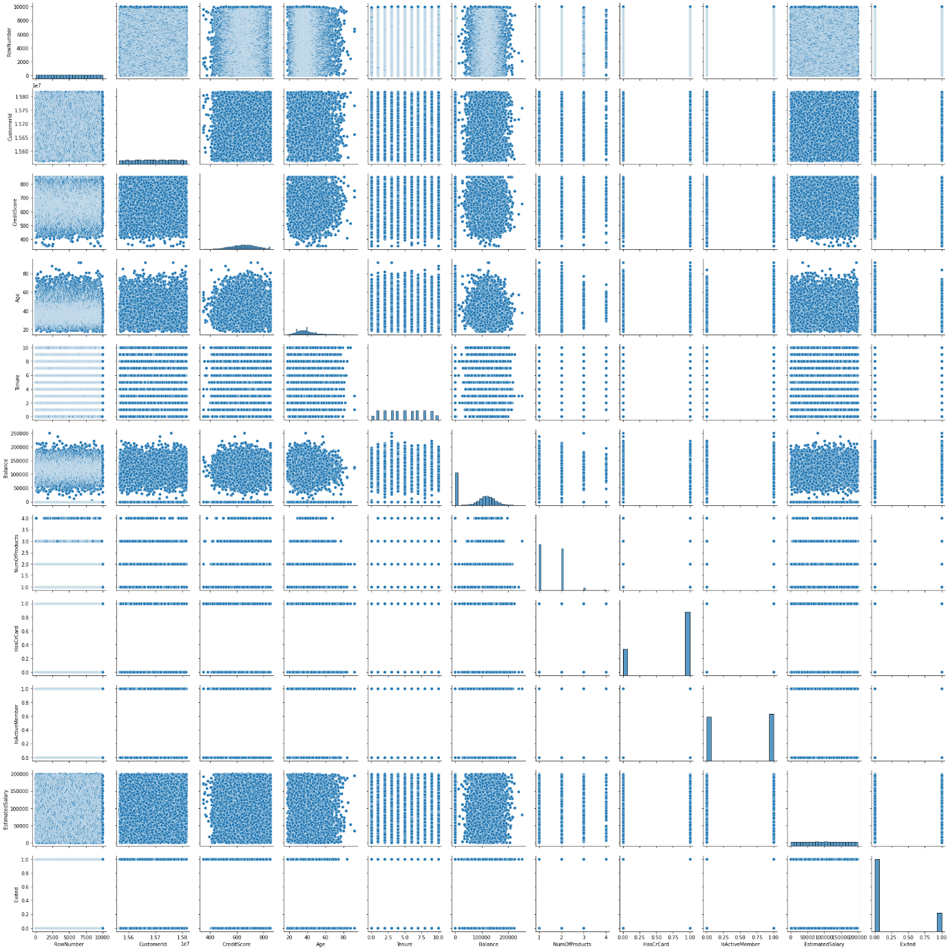

**4. Perform descriptive statistics on the dataset.**

df=pd.read_csv("/Churn_Modelling.csv")

df.describe(include='all')

|  | **RowNumber** | **CustomerId** | **Surname** | **CreditScore** | **Geography** | **Gender** | **Age** | **Tenure** | **Balance** | **NumOfProducts** | **HasCrCard** | **IsActiveMember** | **EstimatedSalary** | **Exited** |
| --- | --- | --- | --- | --- | --- | --- | --- | --- | --- | --- | --- | --- | --- | --- |
| **count** | 10000.00000 | 1.000000e+04 | 10000 | 10000.000000 | 10000 | 10000 | 10000.000000 | 10000.000000 | 10000.000000 | 10000.000000 | 10000.00000 | 10000.000000 | 10000.000000 | 10000.000000 |
| **unique** | NaN | NaN | 2932 | NaN | 3 | 2 | NaN | NaN | NaN | NaN | NaN | NaN | NaN | NaN |
| **top** | NaN | NaN | Smith | NaN | France | Male | NaN | NaN | NaN | NaN | NaN | NaN | NaN | NaN |
| **freq** | NaN | NaN | 32 | NaN | 5014 | 5457 | NaN | NaN | NaN | NaN | NaN | NaN | NaN | NaN |
| **mean** | 5000.50000 | 1.569094e+07 | NaN | 650.528800 | NaN | NaN | 38.921800 | 5.012800 | 76485.889288 | 1.530200 | 0.70550 | 0.515100 | 100090.239881 | 0.203700 |
| **std** | 2886.89568 | 7.193619e+04 | NaN | 96.653299 | NaN | NaN | 10.487806 | 2.892174 | 62397.405202 | 0.581654 | 0.45584 | 0.499797 | 57510.492818 | 0.402769 |
| **min** | 1.00000 | 1.556570e+07 | NaN | 350.000000 | NaN | NaN | 18.000000 | 0.000000 | 0.000000 | 1.000000 | 0.00000 | 0.000000 | 11.580000 | 0.000000 |
| **25%** | 2500.75000 | 1.562853e+07 | NaN | 584.000000 | NaN | NaN | 32.000000 | 3.000000 | 0.000000 | 1.000000 | 0.00000 | 0.000000 | 51002.110000 | 0.000000 |
| **50%** | 5000.50000 | 1.569074e+07 | NaN | 652.000000 | NaN | NaN | 37.000000 | 5.000000 | 97198.540000 | 1.000000 | 1.00000 | 1.000000 | 100193.915000 | 0.000000 |
| **75%** | 7500.25000 | 1.575323e+07 | NaN | 718.000000 | NaN | NaN | 44.000000 | 7.000000 | 127644.240000 | 2.000000 | 1.00000 | 1.000000 | 149388.247500 | 0.000000 |
| **max** | 10000.00000 | 1.581569e+07 | NaN | 850.000000 | NaN | NaN | 92.000000 | 10.000000 | 250898.090000 | 4.000000 | 1.00000 | 1.000000 | 199992.480000 | 1.000000 |

**5. Handle the Missing values.**

from ast import increment_lineno

import pandas as pd

import numpy as np

**5. Handle the Missing values.**

from ast import increment_lineno

import pandas as pd

import numpy as np

import seaborn as sns

import matplotlib.pyplot as plt

%matplotlib inline

sns.set(color_codes=True)

df=pd.read_csv("/Churn_Modelling.csv")

df.head()

|  | **RowNumber** | **CustomerId** | **Surname** | **CreditScore** | **Geography** | **Gender** | **Age** | **Tenure** | **Balance** | **NumOfProducts** | **HasCrCard** | **IsActiveMember** | **EstimatedSalary** | **Exited** |
| --- | --- | --- | --- | --- | --- | --- | --- | --- | --- | --- | --- | --- | --- | --- |
| **0** | 1 | 15634602 | Hargrave | 619 | France | Female | 42 | 2 | 0.00 | 1 | 1 | 1 | 101348.88 | 1 |
| **1** | 2 | 15647311 | Hill | 608 | Spain | Female | 41 | 1 | 83807.86 | 1 | 0 | 1 | 112542.58 | 0 |
| **2** | 3 | 15619304 | Onio | 502 | France | Female | 42 | 8 | 159660.80 | 3 | 1 | 0 | 113931.57 | 1 |
| **3** | 4 | 15701354 | Boni | 699 | France | Female | 39 | 1 | 0.00 | 2 | 0 | 0 | 93826.63 | 0 |
| **4** | 5 | 15737888 | Mitchell | 850 | Spain | Female | 43 | 2 | 125510.82 | 1 | 1 | 1 | 79084.10 | 0 |

**6. Find the outliers and replace the outliers**

import pandas as pd

import matplotlib

from matplotlib import pyplot as pyplot

%matplotlib inline

matplotlib.rcParams['figure.figsize']=(10,6)

df=pd.read_csv("/Churn_Modelling.csv")

df.sample(5)

| **RowNumber** | **CustomerId** | **Surname** | **CreditScore** | **Geography** | **Gender** | **Age** | **Tenure** | **Balance** | **NumOfProducts** | **HasCrCard** | **IsActiveMember** | **EstimatedSalary** | **Exited** |
| --- | --- | --- | --- | --- | --- | --- | --- | --- | --- | --- | --- | --- | --- |
| **120** | 121 | 15682472 | Culbreth | 828 | France | Male | 34 | 8 | 129433.34 | 2 | 0 | 0 | 38131.77 | 0 |
| **2504** | 2505 | 15625942 | McDonald | 619 | Spain | Female | 45 | 0 | 0.00 | 2 | 0 | 0 | 113645.40 | 0 |
| **8432** | 8433 | 15582519 | Seleznyov | 479 | France | Male | 47 | 6 | 121797.09 | 1 | 0 | 1 | 5811.90 | 1 |
| **6931** | 6932 | 15808930 | Mai | 531 | France | Female | 37 | 1 | 0.00 | 1 | 1 | 0 | 4606.97 | 0 |
| **1453** | 1454 | 15714227 | Kelly | 672 | France | Female | 53 | 7 | 0.00 | 1 | 1 | 1 | 136910.18 | 0 |

**7. Check for Categorical columns and perform encoding.**

df=pd.read_csv("/Churn_Modelling.csv")

df.columns

import pandas as pd

import numpy as np

headers=['RowNumber','CustomerID','Surname','CreditScore','Geography',

'Gender','Age','Tenure','Balance','NumofProducts','HasCard'

'IsActiveMember','EstimatedSalary','Exited']

import seaborn as sns

df.head()

|  | **RowNumber** | **CustomerId** | **Surname** | **CreditScore** | **Geography** | **Gender** | **Age** | **Tenure** | **Balance** | **NumOfProducts** | **HasCrCard** | **IsActiveMember** | **EstimatedSalary** | **Exited** |
| --- | --- | --- | --- | --- | --- | --- | --- | --- | --- | --- | --- | --- | --- | --- |
| **0** | 1 | 15634602 | Hargrave | 619 | France | Female | 42 | 2 | 0.00 | 1 | 1 | 1 | 101348.88 | 1 |
| **1** | 2 | 15647311 | Hill | 608 | Spain | Female | 41 | 1 | 83807.86 | 1 | 0 | 1 | 112542.58 | 0 |
| **2** | 3 | 15619304 | Onio | 502 | France | Female | 42 | 8 | 159660.80 | 3 | 1 | 0 | 113931.57 | 1 |
| **3** | 4 | 15701354 | Boni | 699 | France | Female | 39 | 1 | 0.00 | 2 | 0 | 0 | 93826.63 | 0 |
| **4** | 5 | 15737888 | Mitchell | 850 | Spain | Female | 43 | 2 | 125510.82 | 1 | 1 | 1 | 79084.10 | 0 |

**8. Split the data into dependent and independent variables.**

x=df.iloc[:,:-1].values

print(x)

y=df.iloc[:,-1]._values

print(y)

[[1 15634602 'Hargrave' ... 1 1 101348.88]

[2 15647311 'Hill' ... 0 1 112542.58]

[3 15619304 'Onio' ... 1 0 113931.57]

...

[9998 15584532 'Liu' ... 0 1 42085.58]

[9999 15682355 'Sabbatini' ... 1 0 92888.52]

[10000 15628319 'Walker' ... 1 0 38190.78]]

[1 0 1 ... 1 1 0]

**9. Scale the independent variables**

import seaborn as sns

df=pd.read_csv("/Churn_Modelling.csv")

dff=df[['Balance','Age']]

sns.heatmap(dff.corr(), annot=True)

sns.set(rc={'figure.figsize':(40,40)})

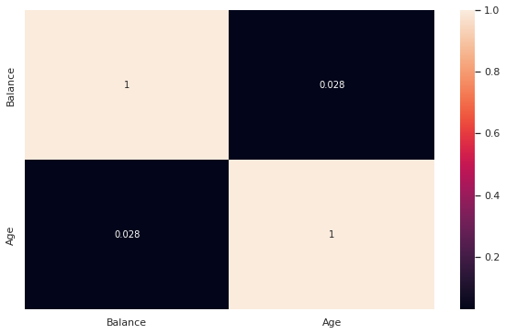

**10. Split the data into training and testing**

from scipy.sparse.construct import random

x=df.iloc[:, 1:2].values

y=df.iloc[:,2].values

from sklearn.model_selection import train_test_split

x_train, x_test, y_train, y_test=train_test_split(x,y,test_size=0.2,random_state=0)

print('Row count of x_train table'+'-'+str(f"{len(x_train):,}"))

print('Row count of y_train table'+'-'+str(f"{len(y_train):,}"))

print('Row count of x_test table'+'-'+str(f"{len(x_test):,}"))

print('Row count of y_test table'+'-'+str(f"{len(y_test):,}"))

Row count of x_train table-8,000

Row count of y_train table-8,000

Row count of x_test table-2,000

Row count of y_test table-2,000